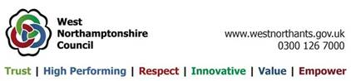 County of Northamptonshire

Yardley Gobion Parish Council

Clerk: Miss L Ratcliffe 9 Moorend Road

Tel: 01908 542150 Yardley Gobion
Towcester
Northants
NN12 7UF

clerk@yardleygobionparishcouncil.gov.uk

10th June 2024

I confirm that the status of the Accounting Statements are unaudited and that the Accounting Statements as published may be subject to change.

L Ratcliffe
Clerk to the Council

